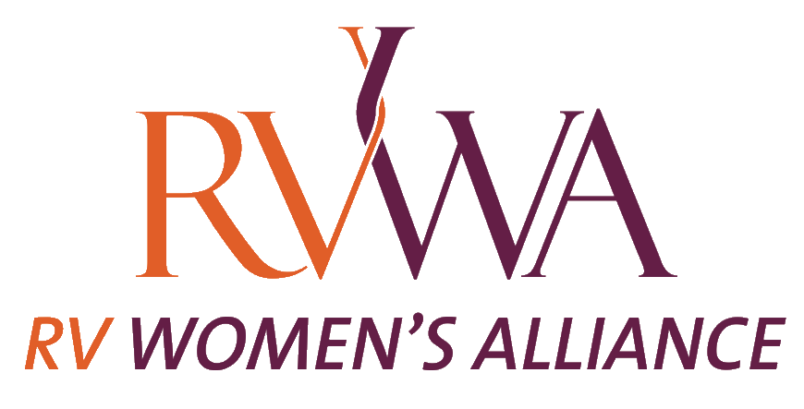

Mentorship Program

We believe that fostering the growth of the next generation of leaders is of utmost importance to the continuation of our prosperous industry. The mission of RVWA is to elevate, educate and promote women in the RV Industry

Our vision for this program is to create a space for women to connect with an industry veteran that can help them grow both personally and professionally. We look to allow a space for women to find another woman that will truly be a resource to help them succeed.

How The Program Works

- Mentor Selection

A Mentor is a chosen member of RVWA who participates and continues to make a difference in the community.
RVWA acknowledges how their contribution is of profound value to the women of the industry. We seek women who will contribute authentically to the Mentorship Program's volunteer role and a Mentee’s career.
A RVWA Mentor naturally assists others in achieving their goals. The following Mentor Qualities are what RVWA seeks for their Mentorship Program:
- High level of attunement in their professional relationships
- Self-efficacy – the belief that they are capable of being a Sponsor
- Aptitude to reflect their motivation and contributions to the relationship
- Relevant Expertise in their business
- Enthusiasm for Sharing their knowledge
- Eagerness to Invest in Others
- Ability to be authentic with Feedback
- Reflective Listening and Empathy
- Mentee Selection
Every quarter, RVWA will send a call out to industry women to fill out a questionnaire to become a Mentor.
All potential Mentee’s will complete a Mentorhship Program Application online. RVWA will review all applications, and will pair a Mentor with a Mentee.
A RVWA Mentee is determined based upon an ideal match for both the Mentor and the Mentee. The Mentor is seeking a Mentee that they can assist in their career and business. The following Mentee Attributes are for guidance purpose only:
- Motivated to succeed by acting on the knowledge she has received
- Committed to the time and execution of the Sponsor’s guidance
- Positivity produces positive results
- Respectful of the time and value the Sponsor is providing
- Willingness to learn and an openness to new ideas
- Clear communication with the Sponsor for efficiency
- Confidence is essential for maximizing performance
- Expectations
Mentor/Mentee can set their own schedule for calls but they are expected to have a call on a monthly basis for the duration of the program.

If at any time during the program either party feels as though the program is no longer beneficial, they can contact RVWA.
Mentor:
An effective Mentor understands that her role is to be dependable, engaged, authentic, and tuned in to the Mentee’s needs. She demonstrates a standard of participation and support with the Mentee; while leveraging her value, she also sees her Mentee’s strengths and assists her in potential vulnerabilities.
Mentee:
An effective Mentee understands that her role is to take the initiative in all agreed- upon actions, keeps commitments, prepared for meetings with their Mentor, and has followed through on action items resulting from the meetings. Remember that your Mentor is there for you but is only a guide. She is also aware of timeliness and dedicates quiet space where one can speak 100% freely during the Zoom calls or other scheduled meetings with her Mentor.

- Developing A Plan, Goals and Objectives
The Mentor will be clear on the 6-month framework and the tasks that need execution from the Mentee to achieve their goals and objectives. It is essential to the Mentorship Programs success that concrete, achievable, and measurable intentions are outlined. Otherwise, it can lead to dissatisfaction and no growth for the Mentee. This also assists the Mentors role in observing outcomes, supporting with their expertise, and time to pivot if the situation or evaluation deems necessary.
- Execution of the Program
Before the first call

Mentee should have a list of 3-5 big goals they are looking to achieve in their professional career and they should share these with the Mentor before the call. This should include why these are the Mentee’s goals, what steps they may have already taken and where they for see getting stuck.

Mentor should review this before the call

During the first call

Set up a regular time to talk either by phone or zoom
Layout communication expectations regarding text, email or other between
formal calls
Discuss big goals for Mentee and determine which you will take action on
first as well as homework items to start achieving that.

Subsequent Calls

These can be set at your own pace and on your own time. They can last
however long both the Mentor and Mentee sees fit.

Program Conclusion

At the end of six months the official Mentorship Program will end.
Both the Mentor and Mentee will be asked to reflect on the program and
provide feedback to RVWA as to the success and/or challenges they faced.

The team at RVWA would like to thank you for being a part of the Mentorship Program. We hope that you gain the knowledge and guidance you are looking for both from being a Mentor and a Mentee in this program. We know you will continue to do great things in this industry and we are excited to watch you grow.

